Phonon Explorer & Auxiliary Programs
Dmitry Reznik and Irada Ahmadova
Preliminary trial version

Release notes: This file contains documentation for the Phonon Explorer software (P. 1-8) and auxiliary programs (P. 9).

The program allows to systematically and efficiently explore datasets obtained on TOF chopper spectrometers such as ARCS.

The main principle: generate and display many constant Q slices at once, with the option to calculate and subtract background and perform multizone fitting.

Main features of the program: The program generates multiple constant-Q slices from either .sqw (HORACE) or .nxs (Mantid) file at once based on user input. It does not crash if Horace or Mantid fails to get the slice for a particular Q. Instead it continues to process other Qs. In addition, only slices with reasonable number of points as defined by the user are kept. Cuts containing no data or only a few points are not saved. The program has 3 phases of data analysis, which can be done all at once or separately. 1. Generate constant-Q slices 2. Compute background, 3. Perform multizone fit.

DO NOT RENAME FILES GENERATED BY THE PROGRAMS!

Installation Instructions:

1. Install the following packages are needed:
Python 3.6
Libraries (Python 3.6 version):
Math
Numpy
Matplotlib
Scipy
Python 2.7 (Only if data are stored in an NXS file)
Libraries (Python 2.7 version):
scikit-image

2. If data are stored in SQW file, install Matlab, HORACE, and matlab engine. Make sure that the Matlab paths are configured so that the Matlab engine can be opened from Python 3.6. (Python 2.7 does not work with Matlab)

3. Copy the RSE folder onto your computer. Do not move files into different subdirectories.

4. In an editor open file RSE_CONSTANTS.py. Enter the folder of the InputParameters.txt into INPUTS_PATH_MAIN

KEY POINTS:
UV matrix Current version of the program assumes that the angles between the uv matrix vectors are at 90 degrees to each other.

Naming of Files. DO NOT rename files or directories generated by the software unless you really know how the software works. It relies on file names for information such as wavevector, etc.

HOW TO RUN THE PACKAGE:
The software contains three programs written in Python: GenerateConstQCuts.py, SubtractBackground.py, and Multifit.py. (If the data are stored in an SQW file, there is also a short Matlab function that is called by one of the programs, but this is seamless from the point of view of the user. See below.)

These programs read a file InputParametes.txt, which contains input parameters together with detailed instructions of the functionality the parameters control. This file needs to be edited in the text editor to provide information specific to the task at hand. There is one file that is used by all three programs.

1 GenerateConstQCuts.py: Generates all constant Q slices necessary for data analysis. One can specify BkgMode=0, if only raw cuts (without background subtraction) and their plots are needed. BkgMode=1 means that background subtraction will be performed. In the latter case, the program also generates cuts to be used for background determination, and no plots are generated.

IMPORTANT: The program will crash if you use the wrong version of Python.
This program has to be run with Python 2.7 if the data are stored in a Mantid-generated NXS file.
This program has to be run with Python 3.6 if the data are stored in a HORACE-generated SQW file. If you are using the SQW data file, the Python code calls the Getslice Matlab routine, which connects to HORACE.

There are two alternative ways to run GenerateConstQCuts.py:
- Generate all slices at the specific reduced wavevector q. I.e. it makes one slice per Brillouin zone for the q specified by the user and save the results as text files in a folder. (See Input File) To do this set QMode=0
- Alternatively, the user can enter a list of wavevectors Q of interest (total wavevectors, not reduced), into a text file that should be placed in the folder assigned to the parameter InputFilesDIR in the InputParameters file.. The program will read this text file and generate a folder containing the slices that correspond to each wavevector. To do this set QMode=1 and assign the name of the text file to parameter “textfile_for_selectedQs” in the InputParameters.txt file. An example of such a file for Q=(5.6 0 1), (5.7 0 1), (5.8 0 1) is in the box on the right. The wavevectors should be in reciprocal lattice units.
5.6 0 1
5.7 0 1
5.8 0 1

Directory structure after running GenerateConstQCuts.py with BkgMode=0. GenerateConstQCuts.py was run once with input parameter ProcessedDataName=Stretching_1
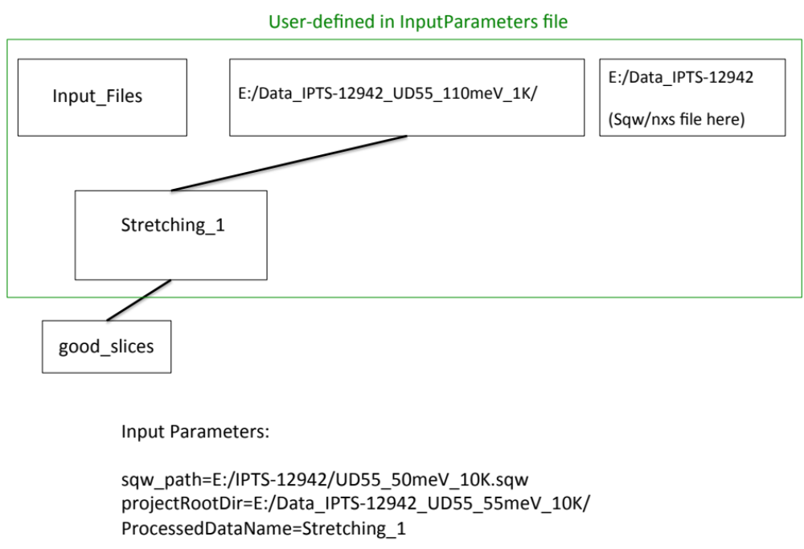

The output data files containing constant Q slices and their plots are stored in the good_slices folder.

2. SubtractBackground.py. Make sure you already ran GenerateConstQCuts.py with the BkgMode parameter set to 1 (BkgMode=1). Then run SubtractBackground.py. This program calculates and subtracts background and also plots all results. It will plot all data (including in Files_for_Background folders) and save background-subtracted files in subdirectory: subtr_background. (see below)

You will have to tweak the following input parameters by trial and error to make sure you obtain good fits to background files:
Resolution, WidthLowerBoundBackground

(See the description of the algorithm below and input parameters in InputParameters.txt.)

Output after running SubtractBackground.py

The following directory structure is created. GenerateConstQCuts.py+ SubtractBackground.py were run once with input parameter ProcessedDataName=Stretching_1 and another time with ProcessedDataName=q=0,0,0

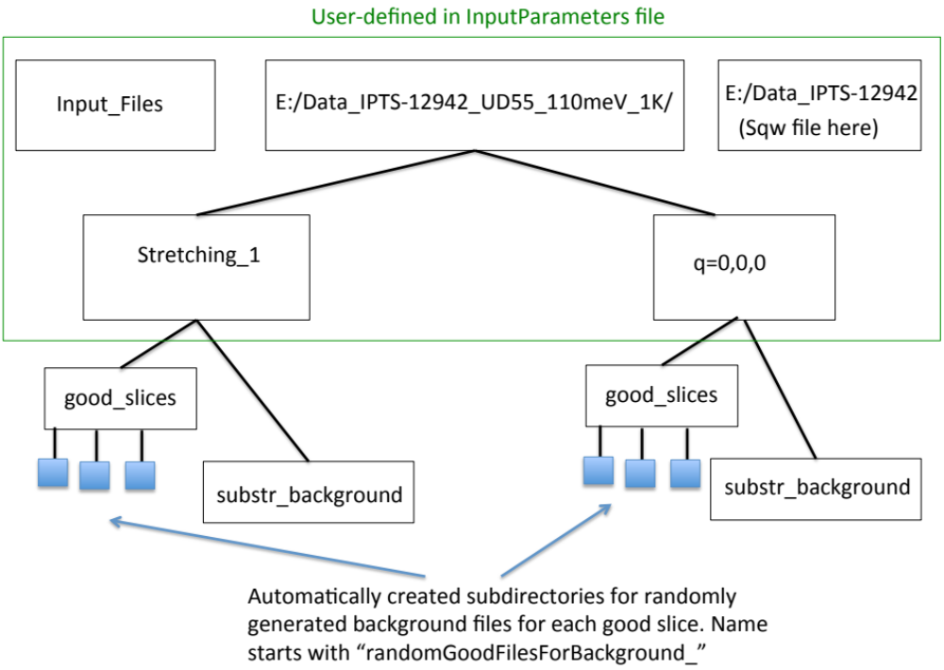

- good_slices: All slices that have a reasonable number of points (more than specified in the MinPointsInDataFile field in the input file) with reasonable (<ErrorToIntensityMaxRation field in the input file, default:30%) error bars are saved in the subdirectory “good slices” under the dataset directory.
Files with background (names start with “B_”) are stored in the same directory. Files used for background determination are saved in in separate subfolders for each good slice (see section How Background Subtraction works below for details). In addition plots are stored in good_slices as well.
- substr_background: Background-subtracted files stored here by the Python part. Results of multizone fitting will be stored here as well.

- Multifit.py. This program performs multizone fit of the files in the subtr_background folder as described in (Phys. Rev. B 89, 064310 (2014)).

The main idea is to fit constant Q cuts for phonons observed in different Brillouin zones but at the same wavevector keeping positions and widths the same in different zones while allowing the amplitudes to vary from zone to zone.

Runs with Python 3.6.

In addition to other input parameters it requires a file where guesses for the peak positions are entered. Example of such a file is the box on the right, where 31, 35 are the initial guesses of peak positions. The name of the file is assigned to parameter position_guesses in InputParameters.txt. Make sure that this file has the right guesses for peak positions.
31 35

Output of this program stored in a file _FittingParam.txt goes to the same subdirectory (subtr_background folder). The file is in the following format:
Example of _FittingParam.txt file. (See text)
1st row – Peak positions
33.5 52.56616861

4.78868355 8.96622224

H-2.50 K 0.00 L 0.00
0.00182147 0.00057426

H-3.50 K 0.00 L 0.00
0.0045662 0.00108261

H-4.50 K 0.00 L 0.00
0.00282977 0.00113734

H-5.50 K 0.00 L 0.00
0.00513573 0.00211125

H-6.50 K 0.00 L 0.00
0.0056896 0.00252221
2nd row – Peak linewidths
3rd row – Wavevector1
4th row Amplitudes at wavevector1
5th row—Wavevector2
6th row – Amplitudes at wavevector2
etc.

Example of this file for two phonons observed in 5 Brillouin zones is shown on the right.

Note that amplitudes are different at every wavevector, but peak positions and widths are the same, since the data files are at the same reduced wavevector: q=(0.5, 0, 0)

Errors are calculated as the sqrt of the diagonal components of the covariance matrix and are stored in the same format in the file named: err_FittingParam.txt

HOW BACKGROUND SUBTRACTION WORKS:

The folder with the Python routines contains a subfolder: Background Tools. This folder contains routines that generate a wavevector (Q’), used in background determination. These are supposed to be written by the user and return a wavevector Q’, where the background should be. These routines can be called more than once if they return different Q’ every time they are called. (e.g. if Q’ is generated based on a random number as is done in the Standard Algorithm supplied with this package). The program does a cut at each Q’ as well as at the original Q. These cuts are saved to the “randomGoodFilesForBackground_...” folder until the user defined maximum number of files (maxFiles parameter). There is one such folder for each Q in good_slices.

These folders are generated by GenerateConstQCuts.py when the BkgMode parameter is set to 1 (BkgMode=1).

SubtractBackground.py program then fits each file in these “randomGoodFilesForBackground_...” folders to multiple Gaussian peaks which produces a smooth curve through each Q’ slice. This minimal width and resolution are specified by the user in the input file and will require some trial and error. (see below) Here is an example of such a plot, which makes the fitting procedure clear. The final curve that goes into the background calculation is the red line obtained as a sum of the individual blue peaks. The purpose is to draw a smooth line through the data

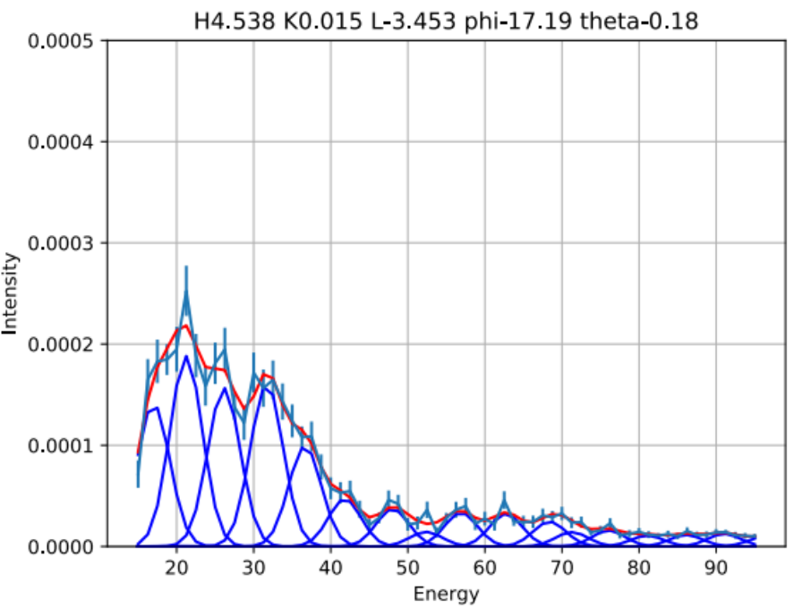
The results of the fit are saved in a text file, which contains fitting parameters. These text files go into the same folder “randomGoodFilesForBackground…” as the randomly generated cuts. Their names start with “_”. The PDF files that start with “H” show these cuts together with the results of the fit. The smooth curves (red) themselves and individual blue peaks are saved in files whose names starts with “fitH..”.

Background is calculated as the minimum of these smooth curves at every energy. An example of randomly generated files together with the background is shown below

Background is subtracted from the original file in good_slices and the result together with the PDF plot is saved in a different folder called “subtr_background”.

Standard Algorithm for calculating Q’s:

The Standard algorithm included with this package generates Q’s at random, so that it needs to be called several times to have good sampling. (See below)

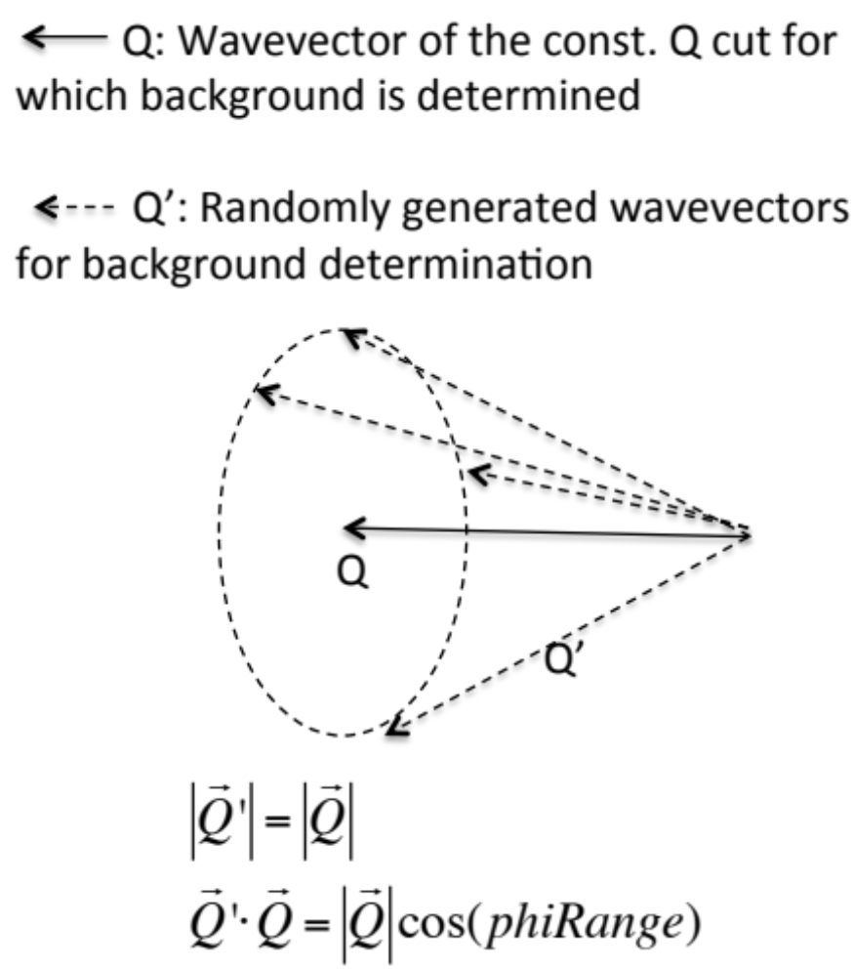
For each Q:
1. Generate slices at random wavevectors Q’ such that |Q|=|Q’| and an angle, phirange, between Q and Q’ is in the range determined by the program (This angle is determined automatically in the current version based of the lattice parameters in CalculatePhiTheta.m). The random slices are saved in “randomGoodFilesForBackground…” folders under “good_slices”. The figure below shows the background (solid blue line) compared with the data at different Q’s
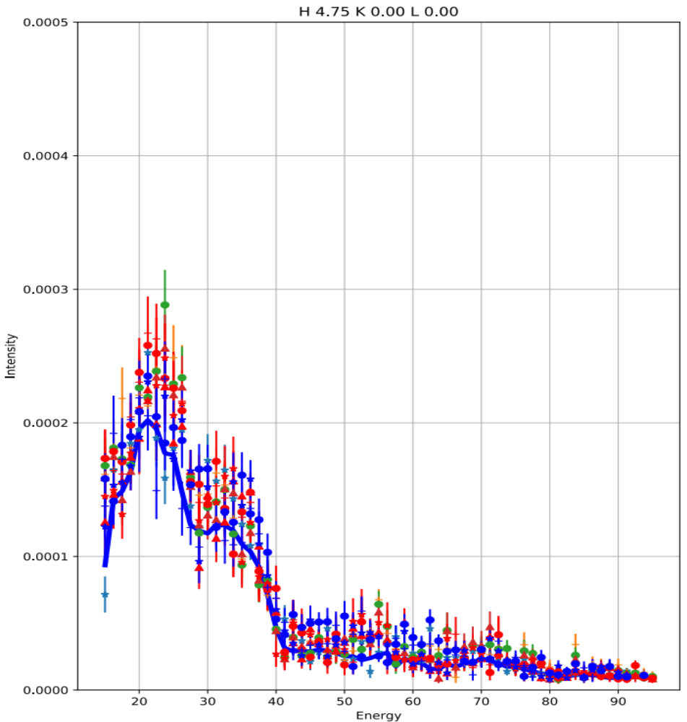
Note that calculating the background this way significantly reduces but not completely eliminates the effect of statistics in the randomly generated cuts. In the end the background comes out slightly smaller than it is supposed to be.

Auxiliary Programs

Background Adjustment functionality allows adjusting background to multiple files by adding a constant.

- Run MakeAdjustmentList.py
It creates a file BackgroundAdjustment.txt in the same folder as the background-subtracted data files. The file has 4 columns:
First 3 are H K L , the 4th column is all zeros.

- Replace zeros in 4th column by the constant amount you wish to subtract from the data, which would normally be different for every H K L.
- Run BackgroundAdjustment.py
The program will subtract these numbers from the data and replot everything.

IMPORTANT: If you rerun SubtractBackground.py, adjustments in BackgroundAdjustment.txt will be applied automatically, if you run BackgroundAdjustment.py again this will done twice!

If BackgroundAdjustment.txt is not there, SubtractBackground.py will not do any adjustments.

compare_data.py allows you to compare data at the same wavevectors coming from two different datasets. Normally it is used when you want to compare data at different temperatures at the same wavevectors. The program automatically makes plots for every wavevector in each directory. Edit the Python file to enter the correct directory names.

